**A**

**Project Report**

**on**

**Kid’s Crown(An Application for dentists).**

**Developed By**

***Prem Ghodake [2205112110082]***

***Nehal Khan [2205112110062]***

**developed at**

**Webmyne systems Private Limited- Vadodara.**

**as**

**Partial Fulfillment of IVth Semester of**

**Master of Computer Applicationsfor A.Y. 2023 - 2024**

**Under The Guidance of**

**Prof. Prashant Halvadiya.**

**Submitted To**

**Department of MCA**

**Faculty of IT & Computer Science**

**PARUL University**





**CERTIFICATE**

This is to certify that **Mr. Prem Ghodake, Enrollment No. 2205112110082 and Mr. Nehal Khan, Enrollment no. 2205112110062** students of Master of Computer Applications have satisfactorily completed the Major Project on **“Kid’s Crown(An application for dentists)”** at **Webmyne Systems Private Limited** as fulfillment of MCA Semester IV.

Seat No. _______________ Date of Submission: ____________

_______________ _______________ _______________

Internal Guide Project Coordinator Director - MCA

**Department of MCA**

**Faculty of IT & Computer Science**

**PARUL University, Vadodara**

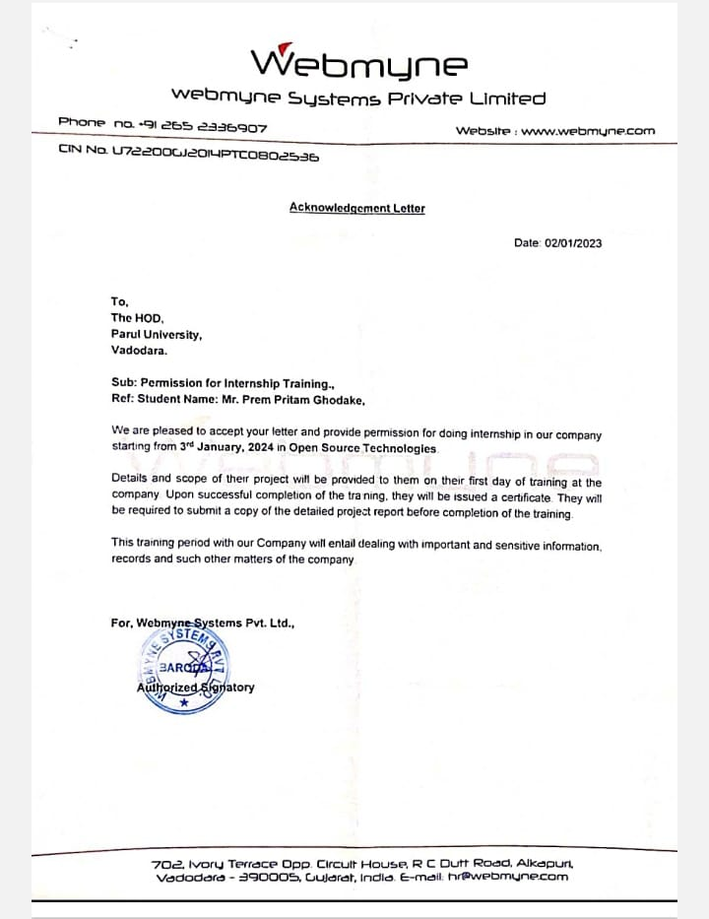

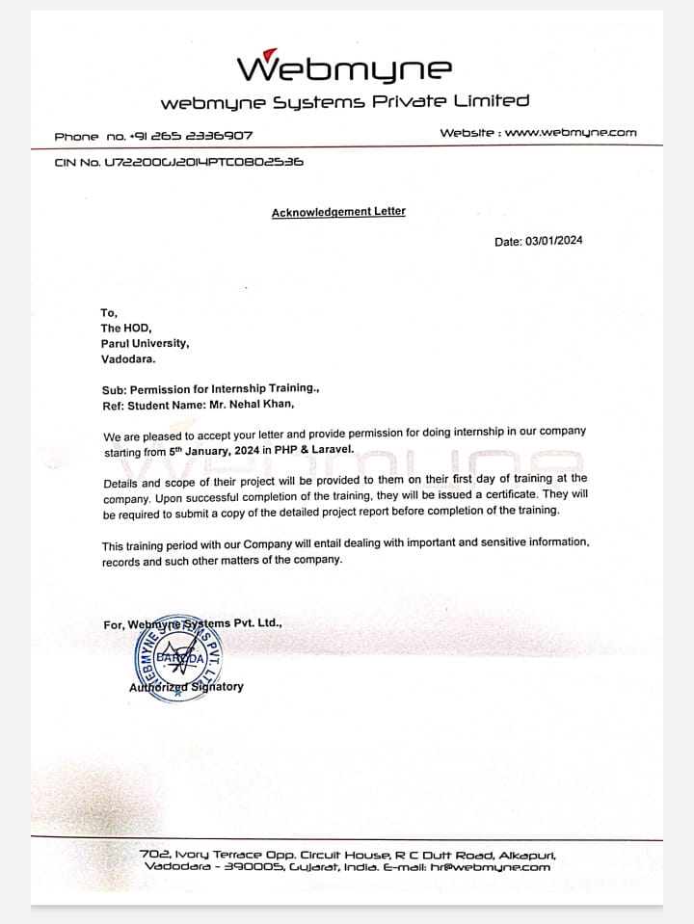

# 

# PREFACE

In the preparation of this project of Accountancy, I have precisely demarcated all the important points. I have made my best possible efforts to remove all the errors. It is a great pleasure for me to thank all those valuable suggestions that have been given to me by Mr. Prashant Halvadiya Sir . I must thank the almighty for this inspiration and guidance as well as my parents, teachers who directed me to complete this project file.

# ACKNOWLEDGMNT

We sincere “THANKS” goes to:

We have thankful to all people to contribute in this Project .And also thanks to this people to helpful us. We would like to thank those without whose support and inspiration this Project Is not successfully published. We have first of all thanks to our Guide prof. Prashant Halvadiya Sir who look us in the right path for the Kids Crown Project And they have been also provided the suggestion and advice. We are also Thanks to our head of department . We are also very thankful to respective principal who gave us an Opportunity to present this Project .

**NDEX**

|  |  |  |
| --- | --- | --- |
| **No.** | **Description** | **Page No.** |
| **1.** | **About Department of MCA** | **1** |
| **2.** | **Company Profile** | **2** |
| **3.** | **Project Profile**  2.1 Project Definition  2.2 Project Description  2.3 Existing System  2.4 Problem Statements  2.5 Need for New System  2.6 Proposed System & Features  2.7 Scope  2.8 Outcomes  2.9 Tools & Technology used  2.10 Project Plan | **3** |
| **4.** | **Requirement Analysis**  3.1 Feasibility Study  3.2 Users of the System  3.3 Modules  3.4 Process Model  3.5 Hardware & Software Requirements  3.6 Use Cases  3.7 Use Case Diagram | **7** |
| **5.** | **Design**  4.1 Use Case Scenarios  4.2 Diagrams  4.2.1 UML  4.2.2 Entity Relationship Diagram  4.3 Data Dictionary | **13** |
| **6.** | **Implementation**  6.1 Form Layouts  6.2 Report Layouts  6.3 Coding Convention (Business Logic) | **30** |
| **7.** | **Testing**  6.1 Test Strategy  6.2 Test Cases | **55** |
| **8.** | **Future Enhancement** | **62** |
| **9.** | **Bibliography** | **63** |

1. **About Department of MCA**

**PARUL University**

Parul University is a legitimate university established under Gujarat Private University Act 2009, after legislation passed by the Government of Gujarat on 26thMarch 2015 giving University status to Parul Group of Institutes functioning under the aegis of Parul Arogya Seva Mandal Trust.

**Faculty of IT & Computer Science**

Faculty of IT and Computer Science, Parul University has materialized as one of the prime IT education providers at global level. Various departments under Faculty of IT and Computer Science strive in preparing IT-industry ready professionals by means of various skill development courses, vocational courses, co-curricular & extra-curricular activities, industry visits and expert lectures.

**MCA Department**

The Department of Master of Computer Application and Master of Science in Information Technology at Parul University emphasizes on building professionals in the domain of computer applications by providing necessary environment by means of facilitating suitable blend of technical and non-technical learning experience. The department cultivates students in various curricular, co-curricular and extra-curricular activities in order to produce future system analysts, system designers, system programmers, application programmers, testing professionals, system managers, project managers, researchers and other leading positions in systems/IT department.

The departments offers various subjects from diversified technical/non-technical areas such as – core IT domain, management, communication skills, mathematics & logic building and rich pool of elective subjects.

The department of MCA and M.Sc. (IT) focuses on project-based learning, and hence students are motivated to work on tiny hands-on projects in practical oriented subjects to get better exposure. Moreover, throughout their MCA studies, students are required to work on around 3 mini/major projects in individual/team to get enough confidence on software-development and thereby become industry-ready.

|  |  |
| --- | --- |
| BO KIDS CROWN WEB APPLICATION | 1 |

**2. Company Profile**

Company Profile

A leading web development company having a global presence, Webmyne focuses on the delicate balance between precision and design functionality for all projects. A holistic approach catering to the nuances of custom web design and product development, Webmyne supports web programming and online marketing facilities for creating total solution packages, which consolidate the client's presence in today's technological world.

A professional and dedicated team of expert engineers and customized development requirements across a variety of platforms and environments such as .NET and PHP, in addition to result developers support oriented SEO on-page and offsite product promotion. Webmyne specializes in internet advertising and marketing services. A versatile content team delivers SEO friendly site contents and off page promotion products, which guarantee top site rankings and enhanced visibility.

Webmyne Services

Offering a wide range of diverse services to partner and clients. With our expert staff we are capable of and have fulfilled IT related requirements to companies around the world.

Company Name: Webmyne System Pvt. Ltd.

Address: 702, ivory terrace opposite circuit house Alkapuri Vadodara, Gujarat

390001

City :Vadodara

URL: [www.webnyne](http://www.webnyne) .com

Company profile IT Company

|  |  |
| --- | --- |
| BO KIDS CROWN WEB APPLICATION | 2 |

**3. Project Profile**

**3.1 Project Definition:**

Kids Crown is an application for purchasing crowns. Application is for only dentists.

**3.2 Project Description**

Kit or Refill. Using add to cart option we can add our items from Kit or Refill according to your need. Checkout then select payment option then confirm our order and continue to payment and deliver .The project objective is to deliver the online shopping application into android platform .This project is an attempt to provide the advantages of online shopping to customers of a real shop. It helps buying the products in the shop anywhere through internet by using an android device. Thus the customer will get the service of online shopping and home delivery from his favorite shop. This system can be implemented to any shop in the locality or to multinational branded shops having retail outlet chains. If shops are providing an online portal where their customers can enjoy easy shopping from anywhere, the shops won’t be losing any more customers to the trending online shops. Since the application is available in the Smartphone it is easily accessible and always available.

The features of this project is first show product there are two types of products first is Kit and the other is Refill then user can add product in add to cart and then also can add Shipping Details there are two types of address details first is Billing Address and the another one is Shipping Address then we want to confirm our order after confirmation we need to pay for the selected product then continue to payment then select preferred payment methods and then pay. Edit user profile and can show orders also give a feedback about your product.

**3.3 Existing System**

Music and music items has become an inevitable part of our life. Music is one of

the greatest so others and healers of an afflicted heart. Customers obtain these music items

from music stores. An existing system is nothing but a manual Music store. A manually run

Music store has so many drawbacks. In such systems the customer will go to such music shops

and search for a specific music CD/Cassette. If the music CD/Cassette is available then only

they will purchase the same. This system has its own drawbacks

Music and music items has become an inevitable part of our life. Music is one of

the greatest so others and healers of an afflicted heart. Customers obtain these music items

from music stores. An existing system is nothing but a manual Music store. A manually run

Music store has so many drawbacks. In such systems the customer will go to such music shops

and search for a specific music CD/Cassette. If the music CD/Cassette is available then only

they will purchase the same. This system has its own drawbacks

Music and music items has become an inevitable part of our life. Music is one of

the greatest so others and healers of an afflicted heart. Customers obtain these music items

from music stores. An existing system is nothing but a manual Music store. A manually run

Music store has so many drawbacks. In such systems the customer will go to such music shops

and search for a specific music CD/Cassette. If the music CD/Cassette is available then only

they will purchase the same. This system has its own drawbacks.

Music and music items has become an inevitable part of our life. Music is one of

the greatest so others and healers of an afflicted heart. Customers obtain these music items

from music stores. An existing system is nothing but a manual Music store. A manually run

Music store has so many drawbacks. In such systems the customer will go to such music shops

and search for a specific music CD/Cassette. If the music CD/Cassette is available then only

they will purchase the same. This system has its own drawbaThe current system for shopping is to visit the shop manually and from the available product choose the item customer want and buying the item by payment of the price of the item .

1. It is less user-friendly.
2. User must go to shop and select products.
3. It is difficult to identify the required product.
4. Description of the product limited.
5. It is a time consuming process
6. Not in reach of distant users

In this systems projects originate from many reasons: to achieve greater speed in processing, better accuracy and improved consistency, faster information retrieval, integration of business areas, reduced cost and better security. The existing system was an automated system. But it was found to be inefficient in meeting the growing demands of population. The purpose of this System is to automate the existing manual system by the help of computerized equipment’s and full-fledged computer software, fulfilling their requirements, so that their valuable data/information can be stored for a longer period with easy accessing and manipulation of the same. The required software and hardware are easily available and easy to work with. It helps the customers to directly earn for their products without any middle men and the buyers can get the fresh products at the very reasonable price from online shopping directly. This System, as described above, can lead to error free, secure, reliable and fast system. It can assist the user to concentrate on their other activities rather to concentrate on the record keeping. Thus it will help organization in better

|  |  |
| --- | --- |
| KIDS KIDS CROWN WEB APPLICATION | 3 |

utilization of resources. The organization can maintain computerized records without redundant entries. That means that one need not be distracted by information that is not relevant, while being able to reach the information.

The aim is to automate its existing manual system by the help of computerized equipment’s and full-fledged computer software, fulfilling their requirements, so that their valuable data/information can be stored for a longer period with easy accessing and manipulation of the same. Basically the project describes how to manage for good performance and better services for the customers.

**3.4 Problem statements**

This projects aims to develop an online shopping for customers with the goal so that it is very easy to shop your loved things from a extensive number of online shopping sites available on the web. With the help of this you can carry out an online shopping from your home. Here is no compelling reason to go to the crowed stores or shopping centers during festival seasons. You simply require a WEB phone and one important payment sending option to shop online.

As online shopping became a trend nowadays the regular shops are losing their customers to online brands. Customers have effortless shopping experience and saving time through shopping online. For competing with those online brands , If shops are providing an online portal where their customers can shop through internet and get the products at their doors it will increase the number of customers. It is simple. You will pick your favourite items from variety of online shopping sites looking at cost and quality. No need to go physical shops with this you will have more time to spend with your family. It Just need a computer and a payment making options like net banking, credit card, debit card or paypal. Almost a wide range of things can be brought through online shopping system you can purchase goods from foreign places from your bedroom and you will get your goods at your home. It is extremely secure. Customer service is accessible.

**3.5 Need for New System**

In the daily life, people face many issues like Due to busy job life, people were unable to go outside to buy the products. So we need for new system, the online shopping (Home shop) is an easy to maintain, ready to run, scalable, affordable and reliable cost saving website from Software Associates suited for small, , and large shopping complex and shopping malls.

Online shopping is the process whereby consumers directly buy goods, services etc from a seller interactively in real-time without an intermediary service over the Internet. If an intermediary service is present the process is called electronic commerce. An online shop, eshop, e-store, internet shop, webshop, webstore, online store, or virtual store evokes the physical analogy of buying products  or services  at a bricks-and-mortar  retailer  or in a shopping mall.

All types of stores have retail web sites, including those that do and do not also have physical storefronts and paper catalogs. Online shopping is a form of electronic commerce used for business-to-business (B2B) and business-to-consumer (B2C) transactions. The online shopping system helps to the customers so that the customers can do his work easily

.

|  |  |
| --- | --- |
| KIDS KIDS CROWN WEB APPLICATION | 4 |

**Features and Benefits :-**

* Providing security
* Low cost
* Basic computer knowledge required
* Configurable and extensible application UI design

**3.6 Proposed System & Features:**

In the proposed system customer need not to go to the shop for buying the products. We can order the products we wish to buy through the application in our smart phone. The shop owner will be admin of the system. Shop owner can appoint moderators who will help owner in managing the customers and product orders. The system also recommends a home delivery system for the purchased products We can save our time also with the help of online shopping applications. It is an Online Shopping application which provide e shopping for everyone. Specific type of products are available according to the website with a range of varieties.

It mainly concentrates on user friendly interfaces and promotes user to purchase faster and easier. Security issue play an important role now a days, so an extra attention is required towards.

The proposed system is having many advantages over the existing system. It require less overhead and very efficient. Various types of products are available for purchase at reliable price. The Kids Crown WEB application focuses on user friendly interfaces and promotes user to purchase the product faster. at reliable price. The Kids Crown WEB application focuses on user friendly interfaces and promotes user to purchase the product faster. In this online shopping application no one can access the information. Security is given utmost importance while designing the website. If any user is not valid then they cannot access the website because of strong validations.

**3.7 Scope:**

This system can be implemented to any shop in the locality or to multinational branded shops having retail outlet chains. The system recommends a facility to accept the orders 24*7 and a home delivery system which can make customers happy.

If shops are providing an online portal where their customers can enjoy easy shopping from anywhere, the shops won’t be losing any more customers to the trending online shopping Since the application is available in the Smartphone it is easily accessible and always available.

|  |  |
| --- | --- |
| B1O KIDS CROWN WEB APPLICATION | 5 |

**3.8 Outcomes**

After using “**Kids Crown**” WEB based application people can easily order the crowns . And we also provide home delivery all over India. Our website helps to provide the products to the customer.

**3.9 Tools & Technology used**

For Developing a Farm Based Web Portal we prefer the languages to make perfect website like:

**Front-end:** - html,css,bootstrap,js etc.

**Back-end:** -PHP

**Database**: -My SQL

**3.10 Project Planning**

Project Schedule is important document to be considered before the project start. It consists of the start and finish of a project. It as a guideline to completed and finished project on time has given. Kids Crown takes four months to develop after passing through several major phases in the development of as system.

|  |  |
| --- | --- |
| BO KIDS CROWN WEB APPLICATION | 6 |

**4. Requirement Analysis**

Requirement Analysis

**4.1 Feasibility Study**

The feasibility study is an evaluation and analysis of the potential of a project which is based on extensive investigation and research to support the process of decision making. Depending on the result of the initial

|  |
| --- |
| **Product** |
| The Project is Kids Crown. |
| **Technical Feasibility** |
| This included the study of function, performance and constraints that my affect the ability to achieve an acceptable system, as described in the System Requirement Specification (SRS), and checked if everything was possible using different type of frontend and backend platforms. The Kids Crown application will be developed using PHP. The team is competent in that. |
| **Social Feasibility** |
| Some training for the user/admin are required but all users are IT literate. |
| **Economic Feasibility** |
| This is a very important aspect to be considered while developing a project. We decided the technology based on minimum possible cost factor. Overall, we have estimated that the benefits the organization is going to receive from the proposed system will surely overcome the initial costs and the later on running cost for system. The application developed within the budget. |
| **Implementation Feasibility** |
| Implementation Feasibility deals with the study of whether the service is environment available with all association members and will be managed according to the system or not. |

*Table1 . Feasibility Study Table*

|  |  |
| --- | --- |
| BO KIDS CROWN WEB APPLICATION | 7 |

Requirement Analysis

**4.2 Users of the System**

There will be one type of Member (User).

* Registered User

##### 4.3 Modules of the System

* Login
* Registration
* Forgot Password
* View/ Edit Profile
* Add to cart
* My orders
* Forgot Password
* Feedback
* Logout

##### 4.4 Process Model

The Software process model chosen for the project is the “Agile Model”.

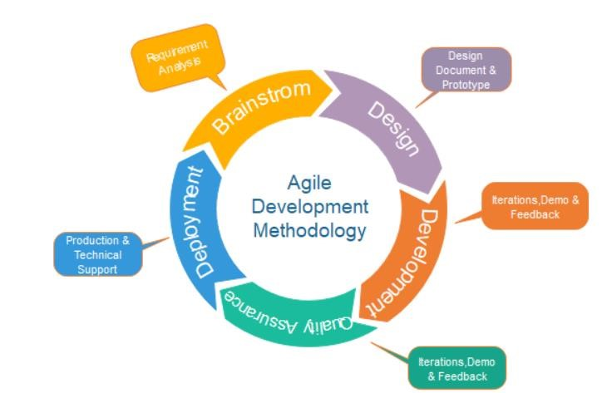

*Figure1. Agile Model Life Cycle*

|  |  |
| --- | --- |
| BO KIDS CROWN WEB APPLICATION | 8 |

**Requirements gathering:** In this phase, Business requirements and system requirements are being gathered from the client.

**Design the requirements:** UI will be prepared first and then implemented.

**Construction/ iteration:** According to User requirements it will be prepare.

**Testing:** UI and various validation testing will be done

**Feedback:** Feedback from the tester, users.

**Advantages of Agile Model**

* Frequent Delivery
* Face-to-Face Communication with clients.
* Anytime changes are acceptable.
* It reduces total development time

**Disadvantages of Agile Model**

* The shortage of formal documents , creates confusion and crucial decisions taken throughout various phases can be misinterpreted at any time by different team members.
* Due to the lack of proper documentation, once the project completes and the developers allotted to another project, maintenance of the finished project can become difficult.

##### 4.5 Hardware & Software Requirements

* **Server-Side Requirements**
* Hardware

|  |  |
| --- | --- |
| Ram | 2 GB |
| SSD | Not Necessary |

*Table.2 Hardware Requirements*

|  |  |
| --- | --- |
| BO KIDS CROWN WEB APPLICATION | 9 |

|  |  |
| --- | --- |
| Operating System | Windows 10 |
| Database | MY SQL |
| Backend | PHP |
| Front-End | HTML,CSS,Bootstrap,Javascript,Ajax,Json |
| Tool | Visual Studio Code |

* Software

*Table.3 Software Requirements*

**Client-Side Requirements**

|  |  |
| --- | --- |
| Ram | 4 GB |
| Device | Android Device |

* Hardware

*Table.4 Hardware Requirements*

* Software

|  |  |
| --- | --- |
| Operating System | Window |
| Application software | XAMP/WAMP |
| Fronted | HTML,CSS, Bootstrap, JavaScript |
| Backend | MYSQL, API |
| Language | PHP |

|  |  |
| --- | --- |
| KIDS CROWN WEB APPLICATION | 10 |

*Table.5 Software Requirements*

|  |  |
| --- | --- |
| BO KIDS CROWN WEB APPLICATION | 11 |

**4.6 Use Cases**

A use case diagram shows various use cases and different types of users the system has and will often be accompanied by other types of diagrams as well. A use case diagram is used to represent the dynamic behavior of a system. It encapsulates the system‟s functionality by incorporating use cases, actors and their relationships. Use case diagrams consist of actors, use cases and their relationships. The diagram is used to model the system/subsystem of an application. A single use case diagram captures a particular functionality of a system. Hence to model the entire system, a number of use case diagrams are used.

To model a system, the most important aspect is to capture the dynamic behavior. Dynamic behavior means the behavior of the system when it is running/operating. Only static behavior is not sufficient to model a system; rather dynamic behavior is more important than static behavior. In UML, there are five diagrams available to model the dynamic nature and use case diagrams are one of them.

**4.7 Use Case Diagram**

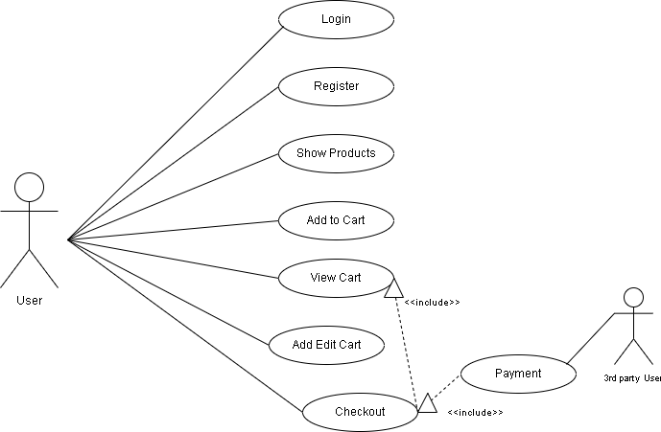

*Fig.2 Use Case Diagram*

|  |  |
| --- | --- |
| BO KIDS CROWN WEB APPLICATION | 12 |

**5. DESIGN**

Design

**5.1 Use Case Scenarios**

|  |  |
| --- | --- |
| Name of the use case | Register |
| Actor | User |
| Primary flow of event | First Name, Last Name, User Name, WEB No, Email Id, Password, Confirm Password, Clinical name, Registration Number. |
| Alternative flow of event | If email, password, name is wrong show message” incorrect the details” |
| Pre-condition | None |
| Post-condition | After successful login Buyer must be redirect to it’s respective dashboard. |
| Use case termination | Cancel |

*Table.6. Use Case Scenario for registration*

|  |  |
| --- | --- |
| Name of the use case | Login |
| Actor | User |
| Primary flow of event | Username, Password |
| Pre-condition | Admin must have login the systems |
| Alternative flow of event | If username or password wrong show message |
| Post-condition | If successful login and come to Home Page. |
| Use case termination | Cancel |

*Table 6: Use Case Scenarios for Login*

|  |  |
| --- | --- |
| BO KIDS CROWN WEB APPLICATION | 13 |

**5.2 Diagrams**

Design

**5.2.1 OOAD Diagrams**

**5.2.1.1 Class Diagram**

\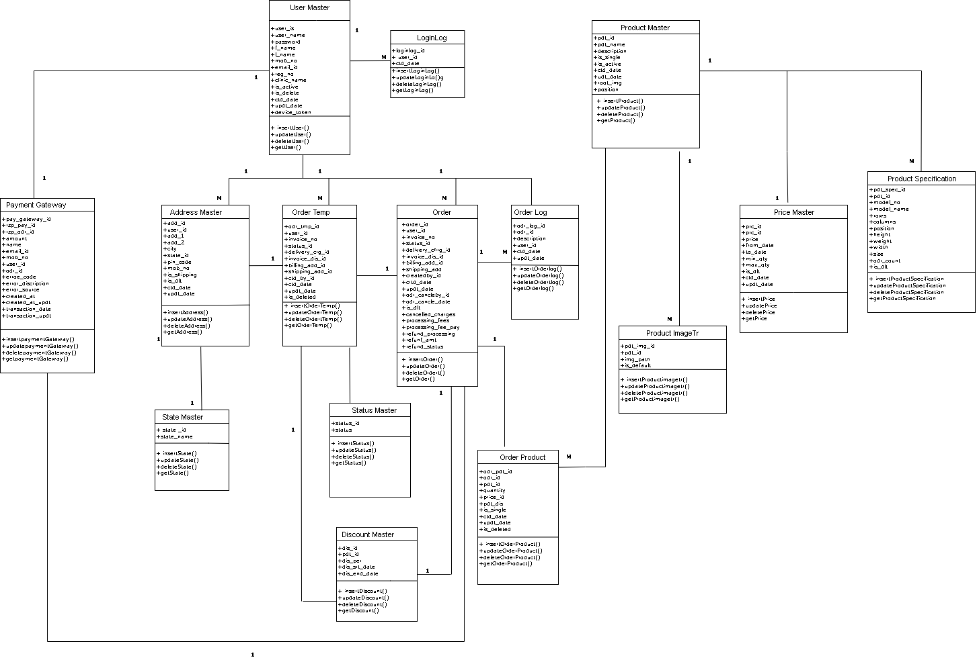

*Figure3.Class Diagram*

|  |  |
| --- | --- |
| KIDS CROWN WEB APPLICATION | 14 |

* + - 1. **Sequence Diagram for Login**

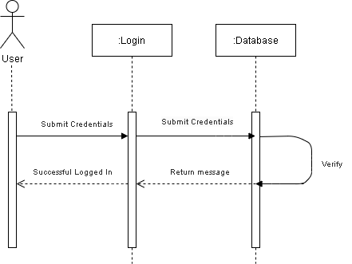

*Figure4.Sequence Diagram for Login*

|  |  |
| --- | --- |
| KIDS CROWN WEB APPLICATION | 15 |

* + - 1. **Sequence Diagram for Register**

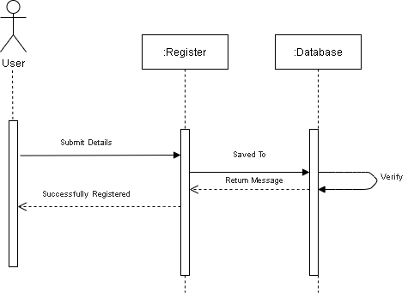

*Figure5.Sequence Diagram for Register*

|  |  |
| --- | --- |
| BO KIDS CROWN WEB APPLICATION | 16 |

* + - 1. **Sequence Diagram for View, Show and Add to Cart Products**

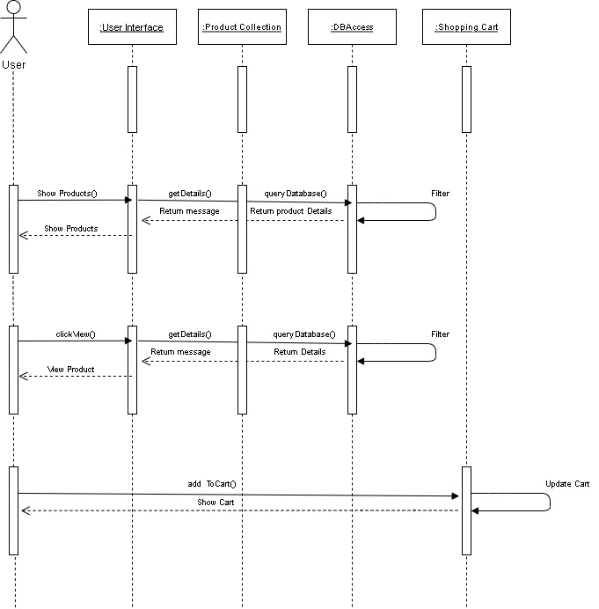

*Figure6.Sequence Diagram for View, Show and Add to Cart Products*

|  |  |
| --- | --- |
| BO KIDS CROWN WEB APPLICATION | 17 |

* + - 1. **Sequence Diagram for Checkout**

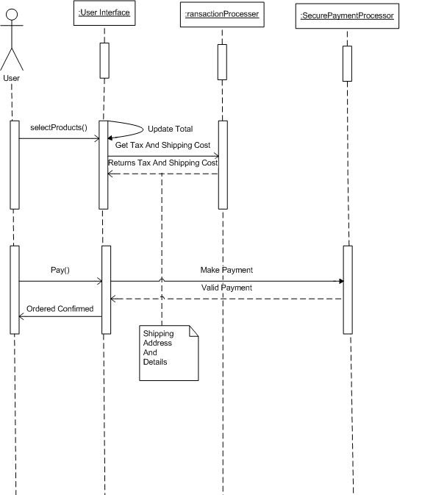

|  |  |
| --- | --- |
| BO KIDS CROWN WEB APPLICATION | 18 |

*Figure7.Sequence Diagram for Checkout*

* + - 1. **Activity Diagram for User**

Design

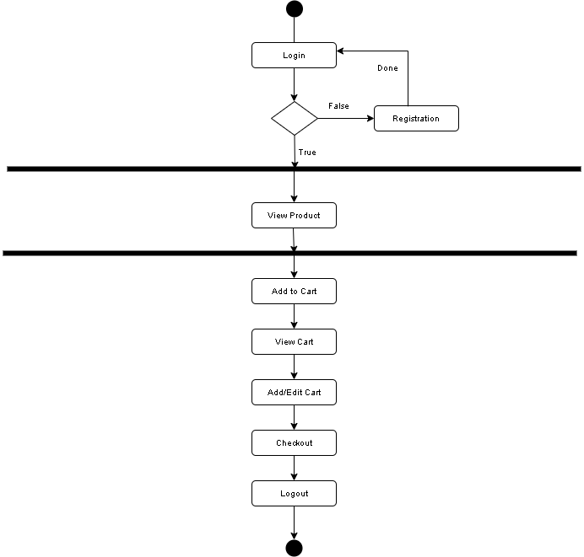

*Figure8.Activity Diagram for User*

|  |  |
| --- | --- |
| BO KIDS CROWN WEB APPLICATION | 19 |

* + - 1. **Collaboration Diagram for User**

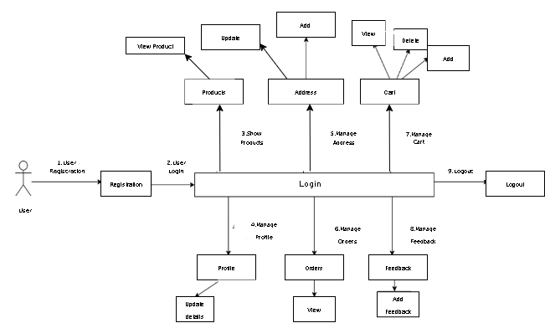

*Figure9.Colloboration diagram for User*

|  |  |
| --- | --- |
| BO KIDS CROWN WEB APPLICATION | 20 |

* + - 1. **Package Diagram**

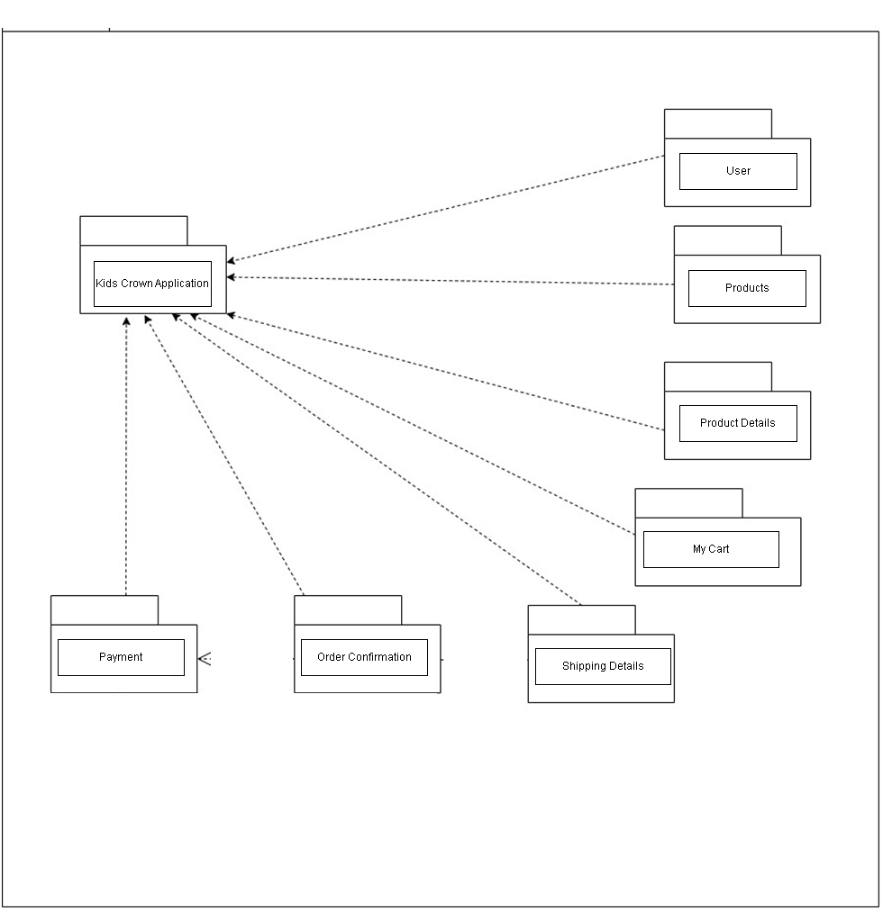

*Figure10.Package diagram*

|  |  |
| --- | --- |
| BO KIDS CROWN WEB APPLICATION | 21 |

* + - 1. **Deployment Diagram**

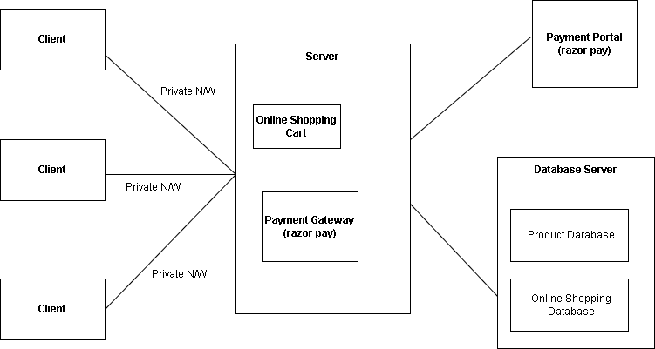

|  |  |
| --- | --- |
| KIDS CROWN WEB APPLICATION | 22 |

*Figure11.Deployment Diagram*

* + - 1. **Entity-Relationship Diagram**

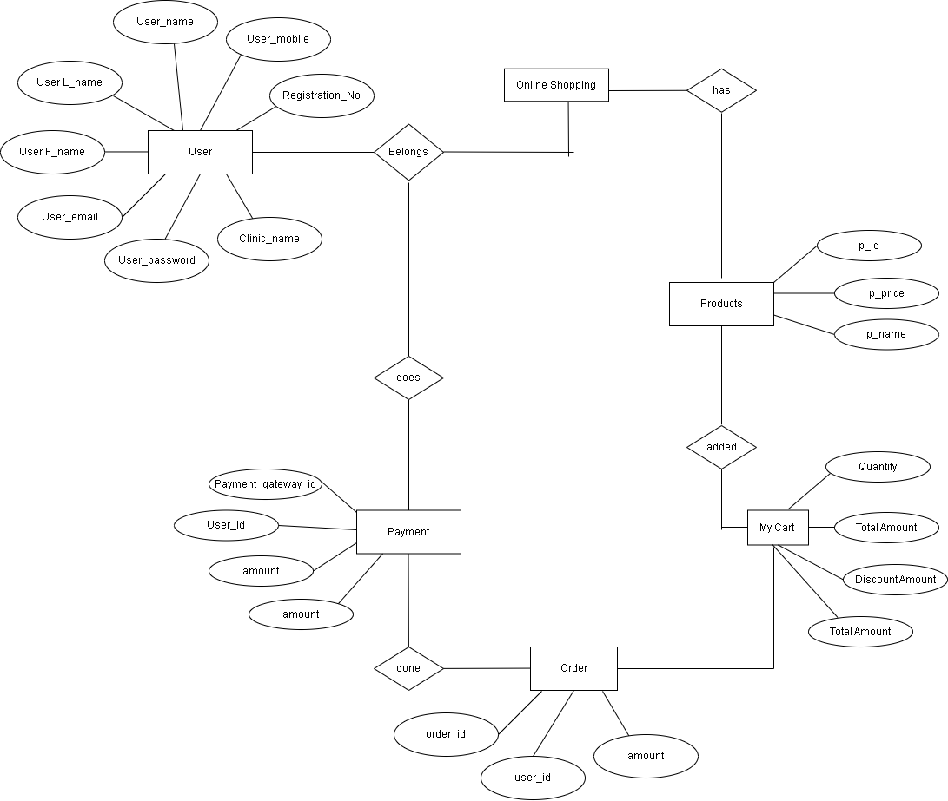

|  |  |
| --- | --- |
| BO KIDS CROWN WEB APPLICATION | 23 |

*Figure12.ER Diagram*

1

1

M

**4.3** **Data Dictionary**

1. **User Master**

|  |  |  |  |
| --- | --- | --- | --- |
| **Fields** | **Constraints** | **Datatype** | **Description** |
| user_id | PK, Auto increment | bigint | Id of user |
| user_name | Not null | nvarchar(256) | Name of user |
| password | Not null | nvarchar(128) | Password of user |
| F_name | Not null | nvarchar(128) | First name of user |
| L_name | Not null | Nvarchar(128) | Last name of user |
| Mob_no | Not null | nvarchar(128) | WEB number of user |
| Email_id | Not null | nvarchar(128) | Email id of user |
| Reg_no | Not null | nvarchar(128) | Registeration number of user |
| Clinic_name | Not null | nvarchar(128) | Clinic Name |
| Is_active | Not null | bit | Active status |
| Is_delete | Not null | bit | Delete status |
| Crtd_date | Not null | datetime | Create date |
| Updated_date | Not null | datetime | Updated date |
| Device_token | Not null | nvarchar(max) | Device token |

Table.1.User Master

1. **LoginLog**

|  |  |  |  |
| --- | --- | --- | --- |
| **Fields** | **Constraints** | **Datatype** | **Description** |
| Loginlog_id | PK, Auto increment | bigint | Id of log |
| User_id | FK, not null | bigint | User id |
| Crtd_date | not null | datetime | Create date and time |

Table.2.LoginLog

**3.ProductImageTr**

|  |  |  |  |
| --- | --- | --- | --- |
| **Fields** | **Constraints** | **Datatype** | **Description** |
| Pdt_img_id | PK, auto increment | bigint | Product id |
| Pdt_id | FK, not null | bigint | Product id |
| Img_path | not null | nvarchar(256) | Image path |
| Is_default | not null | bit | is image shows default |

Table.3.Product ImageTr

|  |  |
| --- | --- |
| BO KIDS CROWN WEB APPLICATION | 24 |

**4. Address Master**

|  |  |  |  |
| --- | --- | --- | --- |
| **Fields** | **Constraints** | **Datatype** | **Description** |
| Add_id | PK, Auto increment | bigint | Address Id |
| User_id | FK, Not null | bigint | User id |
| Add_1 | not null | nvarchar(max) | Address line 1 |
| Add_2 | allow null | nvarchar(max) | Address line 2 |
| City | not null | nvarchar(128) | City name |
| State_id | FK, not null | bigint | State id |
| Pin_code | not null | numeric(10,0) | Pin code |
| Mob_no | not null | numeric(10,0) | WEB number |
| Is_shipping | not null | bit | Is shipping address |
| Is_dlt | not null | Bit | Delete status |
| Ctd_date | not null | datetime | Created date |
| Updt_date | not null | datetime | Update date |

Table.4.Address Master

**5.Product Master**

|  |  |  |  |
| --- | --- | --- | --- |
| **Fields** | **Constraints** | **Datatype** | **Description** |
| Pdt_id | PK, auto increment | bigint | Product id |
| Pdt_name | not null | nvarchar(256) | Product name |
| Description | allow null | nvarchar(max) | Description |
| Is_single | not null | Bit | Is single |
| Is_active | not null | Bit | Delete status |
| Ctd_date | not null | datetime | Created date |
| Udt_date | not null | datetime | Update date |
| Root_img | not null | nvarchar(max) | Root image |
| Position | not null | int | Position of image |

Table.5.Product Master

|  |  |
| --- | --- |
| BO KIDS CROWN WEB APPLICATION | 25 |

**6.Price Master**

|  |  |  |  |
| --- | --- | --- | --- |
| **Fields** | **Constraints** | **Datatype** | **Description** |
| Prc_id | PK, auto increment | bigint | Price id |
| Pdt_id | FK, not null | bigint | Product id |
| Price | not null | numeric(16,2) | price |
| From_date | not null | datetime | From date |
| To_date | not null | datetime | To date |
| Min_Qty | not null | int | Min quantity for order |
| Max_Qty | not null | int | Max quantity for order |
| Is_dlt | not null | bit | Delete status |
| Ctd_date | not null | datetime | Created date |
| Updt_date | not null | datetime | Update date |

Table.6.Price Master

**7.Product Specification**

|  |  |  |  |
| --- | --- | --- | --- |
| **Fields** | **Constraints** | **Datatype** | **Description** |
| Pdt_specId | PK, auto increment | bigint | Price id |
| Pdt_id | FK, not null | bigint | Product id |
| Model_no | not null | nvarchar(256) | Model number |
| Model_name | not null | nvarchar(256) | Model name |
| Rows | not null | numeric(5,0) | Rows |
| Columns | not null | numeric (5,0) | Columns |
| Position | not null | numeric(5,0) | Position |
| Height | not null | numeric(5,0) | Height |
| Weight | not null | numeric(5,0) | Weight |
| Width | not null | numeric(5,0) | Width |
| Size | not null | numeric(5,0) | size |
| Odr_count | not null | numeric(16,2) | Order Amount |
| Is_dlt | not null | bit | Delete Status |

Table.7.Product Specification

**8. State Master**

|  |  |  |  |
| --- | --- | --- | --- |
| **Fields** | **Constraints** | **Datatype** | **Description** |
| State_id | PK, auto increment | Bigint | State id |
| State_name | not null | nvarchar(256) | Status name |

Table.8.State Master

|  |  |
| --- | --- |
| KIDS CROWN WEB APPLICATION | 26 |

**9.Discount Master**

|  |  |  |  |
| --- | --- | --- | --- |
| **Fields** | **Constraints** | **Datatype** | **Description** |
| Dis_id | PK, auto increment | bigint | Discount id |
| Pdt_id | FK, not null | bigint | Product id |
| Dis_percent | not null | numeric(16,2) | Discount percentage |
| Dis_start_date | not null | datetime | Created date |
| Dis_end_date | not null | datetime | Update date |

Table.9.Discount Master

**10.Order**

|  |  |  |  |
| --- | --- | --- | --- |
| **Fields** | **Constraints** | **Datatype** | **Description** |
| Order_id | PK, auto increment | bigint | Order id |
| User_id | FK, not null | bigint | User id |
| Invoice_no | not null | nvarchar(256) | Invoice number |
| Status_id | FK, not null | bigint | Status id |
| Delivery_chrg_id | FK, not null | bigint | Delivery charge id |
| Invoice_dis_id | FK, not null | bigint | Invoice discount id |
| Billing_add_id | FK, not null | bigint | Billing address id |
| Shipping_add | FK, not null | bigint | Shipping address id |
| Createdby_id | FK, not null | bigint | User id |
| Created_date | not null | datetime | Created date |
| Updated_date | not null | datetime | Updated date |
| Odr_cancel_by_ID | not null | bigint | User id |
| Odr_cancel_date | not null | datetime | Order cancel date |
| Is_dlt | not null | bit | Delete Status |
| Cancelled_charges | not null | numeric(16,2) | Cancellation charge |
| Processing_fees | not null | numeric(16,2) | Processing fees |
| Processing_fees_paymt | not null | numeric(16,2) | Processing fees payment |
| Refund_processing | not null | nvarchar(128) | Refund processing status |
| Refund_amt | not null | numeric(16,2) | Refund amount |
| Refund_status | not null | bit | Refund Status |

Table.10.Order

|  |  |
| --- | --- |
| KIDS CROWN WEB APPLICATION | 27 |

**11.Order product**

|  |  |  |  |
| --- | --- | --- | --- |
| **Fields** | **Constraints** | **Datatype** | **Description** |
| Odr_pdt_id | PK, auto increment | bigint | OrderProduct id |
| Odr_id | FK, not null | bigint | Order id |
| Pdt_id | FK, not null | bigint | Product id |
| Quantity | not null | int | Quantity |
| Price_id | FK, not null | bigint | Price id |
| Pdt_dis | not null | numeric(10,2) | Product discount |
| Is_single | not null | Bit | Is single |
| Crtd_date | not null | datetime | Created date |
| Updated_date | not null | datetime | Update date |
| Is_deleted | not null | bit | Delete Status |

Table.11.Order Product

**12.Order Log**

|  |  |  |  |
| --- | --- | --- | --- |
| **Fields** | **Constraints** | **Datatype** | **Description** |
| Ord_log_id | PK, auto increment | bigint | Order Log id |
| Odr_id | FK, not null | bigint | Order id |
| Description | allow null | nvarchar(max) | Description |
| User_id | FK, not null | bigint | User id |
| Crtd_date | not null | datetime | Created date |
| Updated_date | not null | datetime | Update date |

Table.12.Order Log

**13 . Cart Master**

|  |  |  |  |
| --- | --- | --- | --- |
| **Fields** | **Constraints** | **Datatype** | **Description** |
| Odr_tmp_id | PK, auto increment | bigint | Order Log id |
| User_id | FK, not null | bigint | Order id |
| Invoice_no | not null | nvarchar(128) | Invoice number |
| Status_id | FK, not null | bigint | status id |
| Delivery_crg_id | FK, not null | bigint | Delivery charge id |
| Invoice_dis_id | FK, not null | Bigint | Invoice descount id |
| Billing_add_id | FK, not null | Bigint | Billing address id |
| Shipping_add_id | FK, not null | Bigint | Shipping address id |
| Crtd_by_id | FK, not null | Bigint | Created by user id |
| Crtd_date | not null | Datetime | Created date |
| Updt_date | not null | Datetime | Update date |
| Is_deleted | not null | Bit | Delete Status |

|  |  |
| --- | --- |
| BO KIDS CROWN WEB APPLICATION | 28 |

Table.13.Cart Master

1. **Status Master**

|  |  |  |  |
| --- | --- | --- | --- |
| **Fields** | **Constraints** | **Datatype** | **Description** |
| Status_id | PK, auto increment | Bigint | Status id |
| Status | not null | nvarchar(256) | Status name |

Table.14.Status Master

1. **.Delivery charge**

|  |  |  |  |
| --- | --- | --- | --- |
| **Fields** | **Constraints** | **Datatype** | **Description** |
| Delivery_crg_id | PK, auto increment | Bigint | Status id |
| Amount | not null | numeric(10,2) | Amount |
| Mini_amt | not null | numeric(10,2) | Minimum amount |
| Dil_start_date | not null | Datetime | Discount start date |
| Dil_end_date | not null | Datetime | Discount end date |

Table.15.Delivery charge

1. **Payment Gateway**

|  |  |  |  |
| --- | --- | --- | --- |
| **Fields** | **Constraints** | **Datatype** | **Description** |
| Payment_gateway_id | PK, auto increment | Bigint | Peyment Gateway id |
| Rzp__pay_id | not null | nvarchar(max) | Razor pay id |
| Rzp_order_id | not null | nvarchar(max) | Razor order id |
| amount | not null | numeric(10,2) | Payable amount |
| Name | not null | nvarchar(max) | User name |
| email_id | not null | nvarchar(max) | User emailed |
| Mob_no | not null | nvarchar(max) | User WEB number |
| User_id | FK, not null | Bigint | User id |
| Order_id | FK, not null | Bigint | Order id |
| Error_code | not null | Int | Error code |
| Error_discription | not null | nvarchar(max) | Error description |
| Error_source | not null | nvarchar(max) | Error source |
| Created_at | not null | Datetime | Cteated date |
| Created_at_updt | not null | datetime | Creted updated date |
| Transaction_date | not null | datetime | Transaction date |
| Transaction_updt | not null | datetime | Transaction update date |

Table.16.Payment Gateway

|  |  |
| --- | --- |
| BO KIDS CROWN WEB APPLICATION | 29 |

# 

#### 6. Implementation

##### 6.1 Form Layouts

##### 6.1.1 User Registration

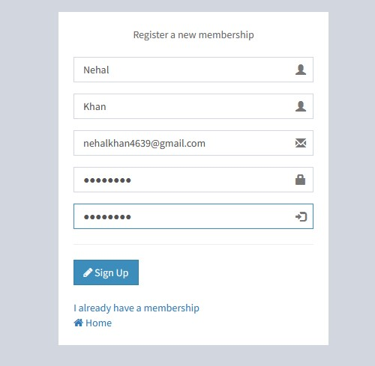

Fig.13. Sign up page for user

**Description:** In this page, any User can create account with valid credentials

|  |  |
| --- | --- |
| BO KIDS CROWN WEB APPLICATION | 30 |

**6.1.2 Login Page**

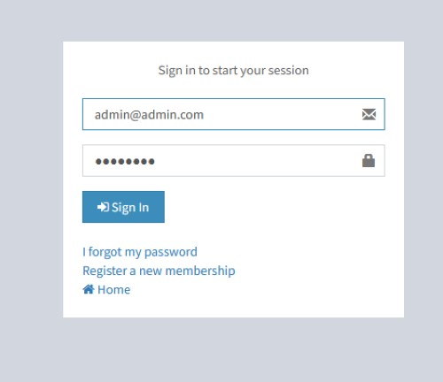

Fig.14.Login Page

**Description**: In this page, any user can create account with valid credentials.

|  |  |
| --- | --- |
| BO KIDS CROWN WEB APPLICATION | 31 |

* + 1. **Dashboard Page**

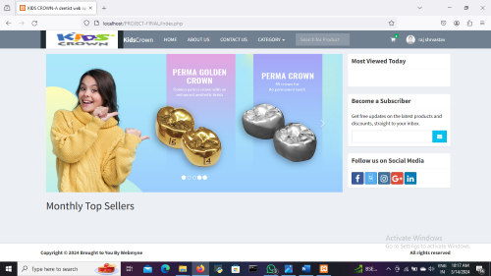

Fig.15.Dashboard Page for User

**Description:** In this page, user can choose any products as per our need.

|  |  |
| --- | --- |
| BO KIDS CROWN WEB APPLICATION | 32 |

##### 6.2 Report Layouts

##### 6.2.1 Products Details

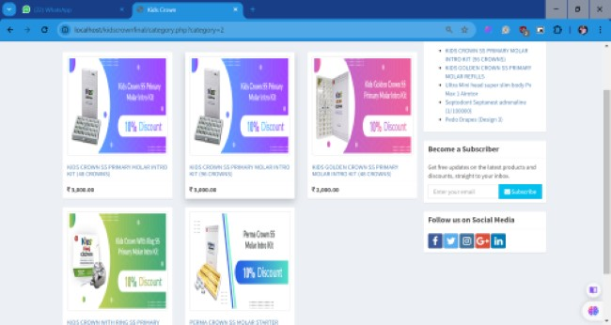

Fig.16. Products menu for user

**Description**: In this page, user can view all the products details.

|  |  |
| --- | --- |
| BO KIDS CROWN WEB APPLICATION | 33 |

##### 6.2.2 Products Details

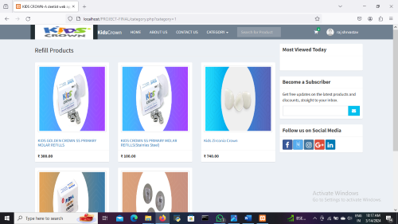

Fig.17. Product menu for user

**Description**: In this page, user can choose the size of Crowns according to the need.

|  |  |
| --- | --- |
| BO KIDS CROWN WEB APPLICATION | 34 |

##### 6.2.3 My Cart Page

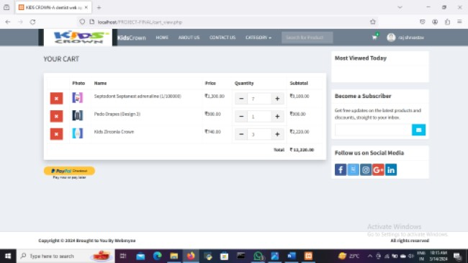

Fig.18. My Cart Page

**Description:** In this page, user can view their card and checkout.

|  |  |
| --- | --- |
| BO KIDS CROWN WEB APPLICATION | 35 |

##### 6.2.4 Shipping Address Details Page

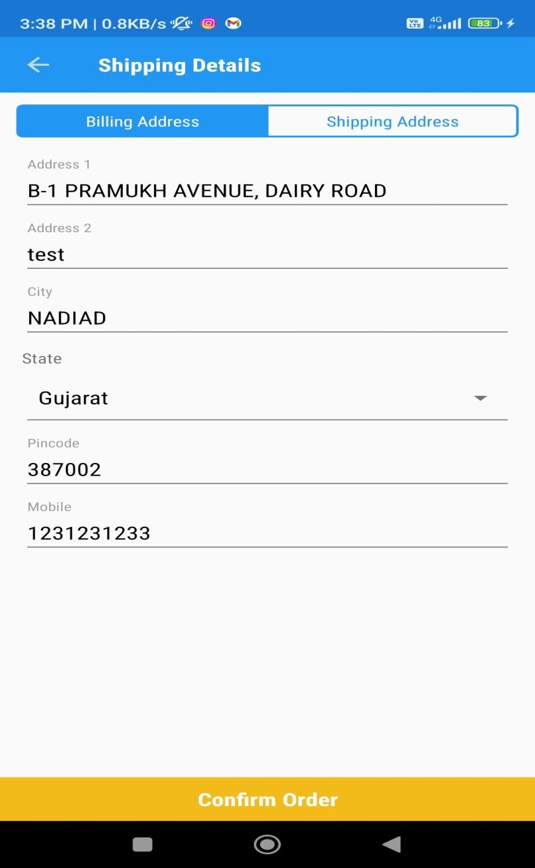

Fig.19. Shipping Address Details Page

**Description:** In this page, user can add the shipping address details.

|  |  |
| --- | --- |
| BO KIDS CROWN WEB APPLICATION | 36 |

##### 6.2.5. Continue to Payment Page

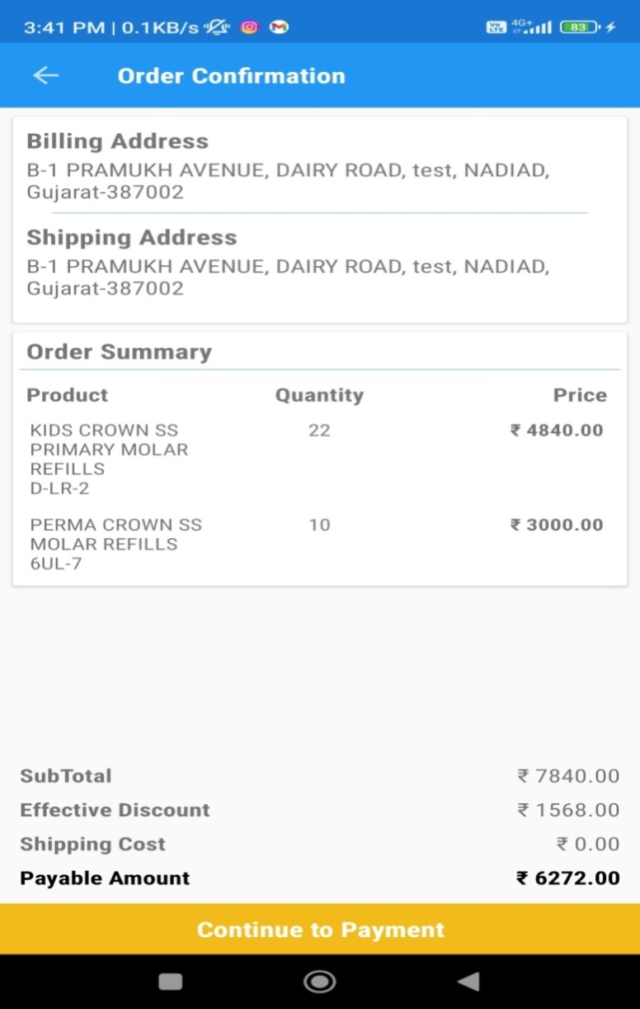

Fig.20. Continue to Payment Page

**Description**: In this page, user can confirm their order by continuing to payment.

|  |  |
| --- | --- |
| BO KIDS CROWN WEB APPLICATION | 37 |

**6.2.6. Edit Profile Page**

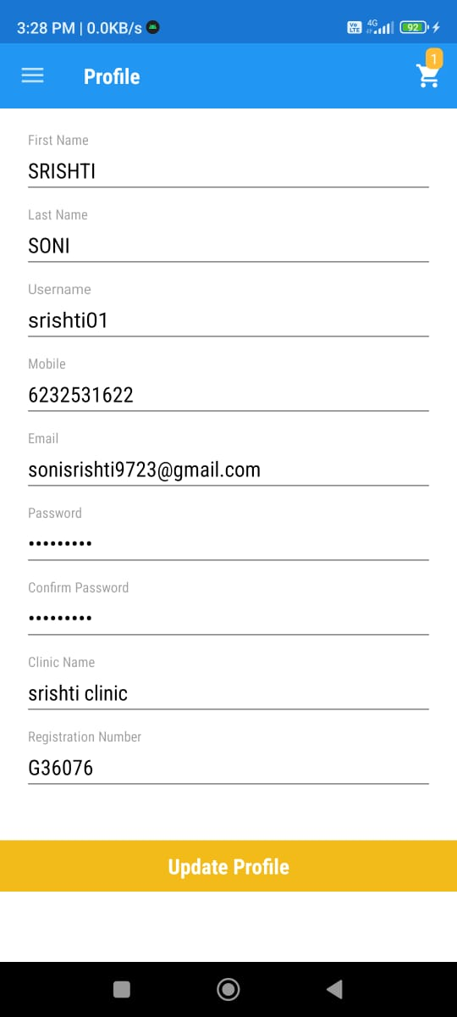

Fig.21. Edit Profile Page

**Description**: In this page , User edit our Profile.

|  |  |
| --- | --- |
| BO KIDS CROWN WEB APPLICATION | 38 |

##### 6.2.7. My Orders Page

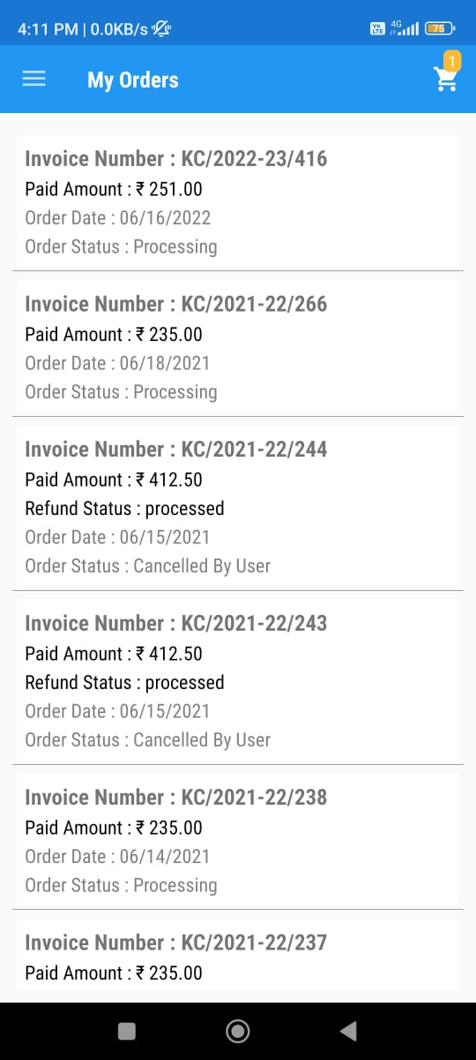

Fig.22. My Orders Page

**Description**: This is the my orders page.

|  |  |
| --- | --- |
| BO KIDS CROWN WEB APPLICATION | 39 |

##### 6.2.8 .Order Details Page

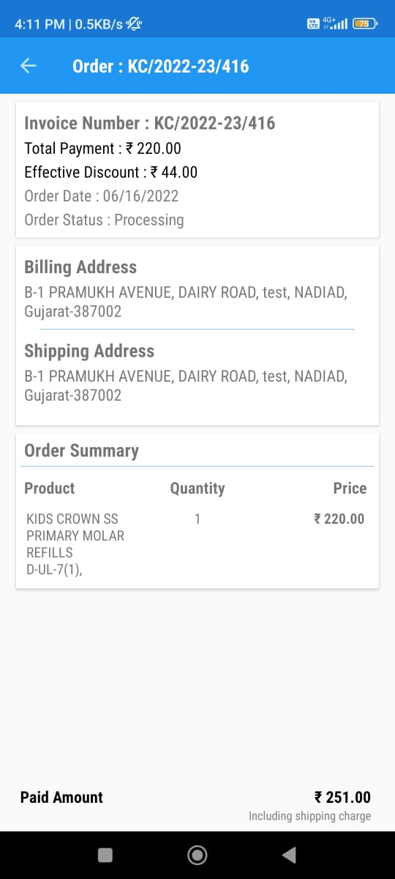

Fig.23. Order Details Page

**Description**: In this Page, User check the order details.

|  |  |
| --- | --- |
| BO KIDS CROWN WEB APPLICATION | 40 |

##### 6.2.9. Contact Us Page

##### 

##### 

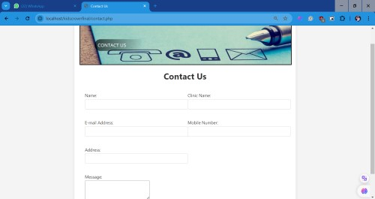

Fig.24.Contact Us Page

**Description**: This is the Contact Us Page.

|  |  |
| --- | --- |
| BO KIDS CROWN WEB APPLICATION | 41 |

**6. Testing**

Testing

**6.1 Test Strategy**

The purpose of testing is to discover errors. Testing is the process of trying to discover every conceivable fault or weakness in a work product. It provides a way to check the functionality of components, sub-assemblies, assemblies and/or a finished product It is the process of exercising software with the intent of ensuring that the software is working properly or not.

Here this application has many fields so for that field testing is going to apply for every field at back end some patterns are used to validate input which is given by user. So basically field validator validates a user input and using it application can take valid data from user.

**Why testing is done**

* Testing is the process of running a system with the intention of finding errors.
* Testing enhances the integrity of a system by detecting deviations in design and errors in the system.
* Testing aims at detecting error-prone areas. This helps in the prevention of errors in a system.
* Testing also add value to the product by confirming to the user requirements.

**Causes of Errors**

The most common causes of errors in a software system are:

* **Communication gap between the developer and the business decision maker:** A communication gap between the developer and the business decision maker is normally due to subtle differences between them. The differences can be classified into five broad areas: Thought process, Background and Experience, Interest, Priorities, Language.
* **Time provided to a developer to complete the project:** A common source of errors in projects comes from time constraints in delivering a product. To keep to the schedule, features can be cut. To keep the features, the schedule can be slipped. Failing to adjust the feature set or schedule when problems are discovered can lead to rushed work and flawed systems.

|  |  |
| --- | --- |
| BO KIDS CROWN WEB APPLICATION | 42 |

* **Over Commitment by the developer:** High enthusiasm can lead to over commitment by the developer. In these situations, developers are usually unable to adhere to deadlines or quality due to lack of resources or required skills on the team.
* **Insufficient testing and quality control:** Insufficient testing is also a major source of breakdown of e-commerce systems during operations, as testing must be done during all

phases of development.

Testing

**Testing Principles**

* To discover as yet undiscovered errors.
* All tests should be traceable to customer’s requirement.
* Tests should be planned long before the testing actually begins.
* Testing should begin “in the small” & progress towards “testing in the large”.
* Exhaustive Testing is not possible.
* To be most effective training should be conducted by an Independent Third Party

**Testing Objectives**

* Testing is a process of executing a program with the intent of finding errors.
* A good test case is one that has a high probability of finding an as yet undiscovered error.
* A successful test is one that uncovers an as yet undiscovered error.

**Types of Testing**

**Black Box Testing- Not** based on any knowledge of internal designs or code. Tests are based on requirements and functionality.

**White Box Testing-** Based on the knowledge of the internal logic of an application’s code. Tests are based on coverage of code statements, branches, paths and statements.

**Unit Testing-** The most ‘micro’ scale of testing; to test particular functions and code modules. Typically done by the programmer and not by the testers, as it requires detailed knowledge of the internal program design and code. Not always

easily done unless the application has a well-designed architecture with tight code; may require developing test driver modules or test harnesses.

**Integration Testing-** Testing of combined parts of an application to determine if they function together correctly. The ‘parts’ can be code modules, individual applications, client and server applications on a network, etc. This type of testing is especially relevant to client/ server and distributed systems.

**Functional Testing-** Black-box type testing geared to functional requirements of an application; testers should do this type of testing. This doesn’t mean that the programmers shouldn’t check that their code works before releasing it.

|  |  |
| --- | --- |
| BO KIDS CROWN WEB APPLICATION | 43 |

Testing

**Acceptance Testing-** Final testing based on the specifications of the end user or customer or based on use by end-users/ customers over some limited period of time.

**User Acceptance Testing-** Determining if software is satisfactory to an end user customer.

**Features to be tested**

* Verify that the entries are of the correct format.
* No duplicate entries should be allowed.
* All links should take the user to the correct page.

**6.2 Test Cases**

In software engineering, a **test case** is a specification of the inputs, execution conditions, testing procedure, and expected results that define a single test to be executed to achieve a particular [software testing](https://en.wikipedia.org/wiki/Software_testing) objective, such as to exercise a particular program path or to verify compliance with a specific requirement.[[1]](https://en.wikipedia.org/wiki/Test_case#cite_note-1) Test cases underlien testing that is methodical rather than haphazard. A battery of test cases can be built to produce the desired coverage of the software being tested. Formally defined test cases allow the same tests to be run repeatedly against successive versions of the software, allowing for effective and consistent [regression testing](https://en.wikipedia.org/wiki/Regression_testing)  test case is usually a single step, or occasionally a sequence of steps, to test the correct behaviour/functionality, features of an application. An expected result or expected outcome is usually given.

Additional information that may be included:

* **Test Case ID** - This field uniquely identifies a test case.
* **Test case Description/Summary** - This field describes the test case objective.
* **Test steps** - In this field, the exact steps are mentioned for performing the test case.
* **Pre-requisites** - This field specifies the conditions or steps that must be followed before the test steps executions.
* **Test category**
* **Author-** Name of the Tester.
* **Automation -** Whether this test case is automated or not.

Testing

Testing

* **Pass/fail**

|  |  |
| --- | --- |
| BO KIDS CROWN WEB APPLICATION | 44 |

**7.2 Test Cases**

Testing

**7.2.1 Module 1: Login**

|  |  |  |  |  |  |  |  |  |  |
| --- | --- | --- | --- | --- | --- | --- | --- | --- | --- |
| **Test Case Scenario ID:** | | |  | **1** | | **Test case ID:** | | **1** | |
| **Test Case Description:** | | |  | To test Login module | | **Test Priority:** | | **HIGH** | |
| **Pre-requisite:** | | |  | Registration is required. | | **Post-requisite:** | | Close the browser | |
| **Test Execution Step:** | | |  | User needs to give email id/password when it is provided when ask for login. | | | | | |
| **Sr. No** | **Test Action** | | **Test data** | | **Browser** | | **Expected Result** | **Actual Result** | **Pass/**  **Fail** |
| 1.1 | 1.2.  3. | Enter Username/Email id and  Enter Password Click on Login button | [sonisrishti9723@gmail.com](mailto:sonisrishti9723@gmail.com)  srisht@1i  Login clicked | | Any  Browser | | User gets logged in | As Expected | Pass |
| 1.2 | 1.2.  3. | Enter email id  Enter Password Click on Login button | [sonisrishti9723@gmail.com](mailto:sonisrishti9723@gmail.com)  srishti@1  Login clicked | | Any  Browser | | User should not get logged in | As Expected, | Pass |

Figure 15: Test case for login

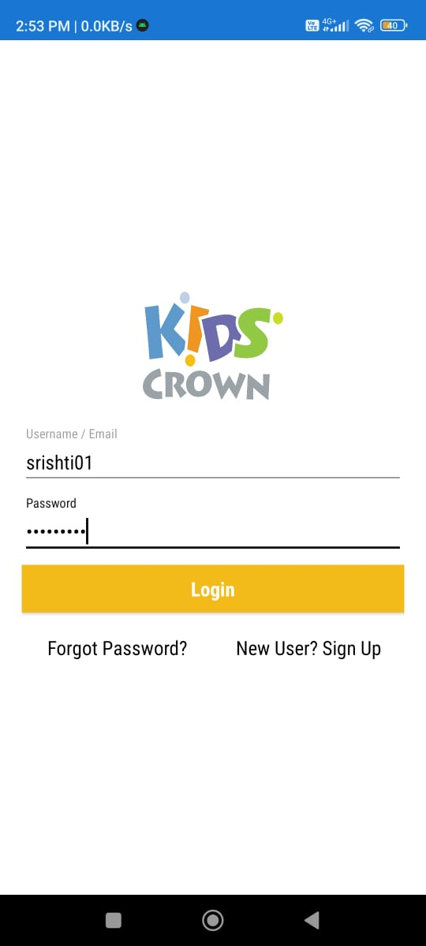

|  |  |
| --- | --- |
| BO KIDS CROWN WEB APPLICATION | 45 |

Figure 25: Login page

**7.2.2 Module 2: Registration**

Testing

|  |  |  |  |  |  |  |  |  |
| --- | --- | --- | --- | --- | --- | --- | --- | --- |
| **Test Case Scenario ID:** | | **2** | | **Test case ID:** | | **2** | | |
| **Test Case Description:** | | Test the registration module | | **Test Priority:** | | **HIGH** | | |
| **Pre-requisite:** | | User should be logged in | | **Post-requisite:** | | None | | |
| **Test Execution Step:** | | User needs to give username/password when it is provided when ask for registration. | | | | | | |
| **Sr.No** | **Test Action** | | **Test Input** | **Expected Result** | **Actual Result** | | **Pass/**  **Fail** |
| 2.1 | 1. Enter First Name | | 1.First name entered | User should get Signed-Up | As Expected. | | Pass |
|  | 2.Enter Last Name | | 2.Last name entered | User should get Signed-Up | As Expected. | | Pass |
|  | 3.Enter User Name | | 3.User name entered | User should get Signed-Up | As Expected. | | Pass |
|  | 4.EnterWEB No. | | 4.WEB no. entered | User should get Signed-Up | As Expected. | | Pass |
|  | 5.Enter Email-id | | 5.Email-id entered | User should get Signed-Up | As Expected. | | Pass |
|  | 6.Enter Password | | 6.Password entered | User should get Signed-Up | As Expected. | | Pass |
|  | 7.Enter Confirm password | | 7.Confirm Password entered | User should get Signed-Up | As Expected. | | Pass |
|  | 8.Enter Clinic Name | | 8.Clinic name entered | User should get Signed-Up | As Expected. | | Pass |
|  | 9.Enter Registration no. | | 9.Registration no entered | User should get Signed-Up | As Expected. | | Pass |

Table.16: Test Case for Registration

|  |  |
| --- | --- |
| BO KIDS CROWN WEB APPLICATION | 46 |

|  |  |  |  |  |  |
| --- | --- | --- | --- | --- | --- |
| 2.2 | 1. Enter First Name | 1.First name | Error message for wrong first name  Testing | As Expected. | Pass |
|  | 2.Enter Last Name | 2.Last name | Error message for wrong last name | As Expected. | Pass |
|  | 3.Enter User Name | 3.User name | Error message for wrong username | As Expected. | Pass |
|  | 4.EnterWEB No. | 4.WEB no. entered | Error message for wrong WEB no | As Expected. | Pass |
|  | 5.Enter Email-id | 5.Email-id | Error message for wrong email- id | As Expected. | Pass |
|  | 6.Enter Password | 6.Password entered | Error message for wrong password | As Expected. | Pass |
|  | 7.Enter Confirm password | 7.Confirm Password | Error message for wrong confirm password | As Expected. | Pass |
|  | 8.Enter Clinic Name | 8.Clinic name | Error message for wrong clinic name | As Expected. | Pass |
|  | 9.Enter Registration no. | 9.Registration no entered | Error message for wrong registration number | As Expected. | Pass |

Figure 15: Test case for Registration

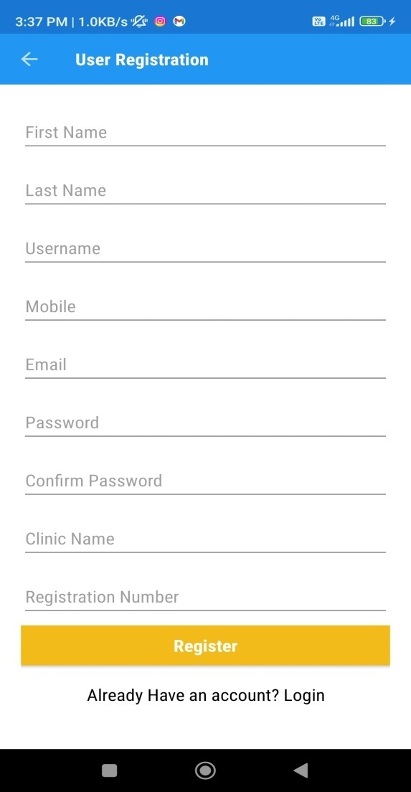

|  |  |
| --- | --- |
| BO KIDS CROWN WEB APPLICATION | 47 |

Figure 26: Registration page

**7. Future Enhancement**

Future Enhancement

* For future enhancement we would like to have auction events, award functions. Different Payment gateways, different reports. And save history or recently visited artworks in our application. Application of Kids Crown will be compatible with IOS and android both.
* We will also add the OTP/SMS functionality in future.
* Updating the software according the user’s needs.
* More efficient and easier categorical search engine.

|  |  |
| --- | --- |
| BO KIDS CROWN WEB APPLICATION | 48 |

Bibliography

**8. Bibliography**

**8.1 Website and documentation**

1. <https://www.mkyong.com>
2. <https://www.google.android.developer.com>

|  |  |
| --- | --- |
| BO KIDS CROWN WEB APPLICATION | 49 |